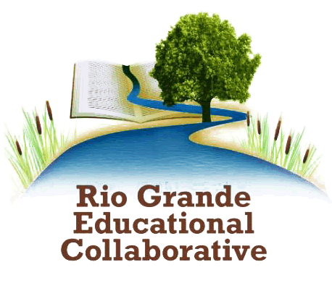
RGEC Before & After School
Enrollment Requirements

- Families will be required to apply for Child Care Assistance from ECECD to enroll their
child with RGEC Programs. https://www.nmececd.org/child-care-assistance/
Proof of application is required.

- If a family does not qualify for CCA, they will receive a document or email from ECECD stating denial. A copy of this communication must be submitted to RGEC.

- Completed Student Registration form for each child attending

ECECD Child Care Assistance Guidelines
If a family's household income is 400% or less of the Federal Poverty Guidelines, it is most likely that the family will qualify for Child Care Assistance (CCA) through NM ECECD.

Families are eligible for financial assistance if they meet the state's low-income guidelines and
need childcare to work, looking for work (TANF), or are attending employment training.

If you are attending school, you may also be eligible.

You are guaranteed childcare if you are on Public Assistance and need childcare to meet any
work participation requirements.

If you left Public Assistance for a job and need childcare to go to work, you are guaranteed
assistance in paying for childcare for one year after leaving Public Assistance.

Eligibility is based on:
■ income ■ your reasons for needing day care ■ your child's age and individual needs

For more information on Child Care Assistance, contact your regional ECECD office or call Early Childhood Services at (505)841-4801 or
1-800-832-1321 or by email at ececd.cca-north@state.nm.us.or apply online at nmececd.org.

