ORGANIZING THE COMMUNITY PROJECT:

MYP teachers collaborated and began the process by answering these questions...

When organizing the project, schools should consider:

• The number of supervisors required
1 mentor per group.
3 Key Yr 3 teachers - Language and Literature, Art and Individual & Societies
MYP Coordinator (Math) Trained in all subject areas.

• The selection and training of supervisors
Experience, recent training and connections with students.

• Informing students about the project
Provocations - get them interested.
Sharing of booklet
Newsletter - Advertising, coming attraction.

• Timelines for supervisors and students
Written in a booklet for reference.

• Scheduling time for supervisors to meet with students individually or in groups
Advisory lessons.

• Documentation for managing the project
Google classrooms, community project booklet.
Supervisor meeting forms
Academic Honesty Form

• Library or information and communication technology resources for the project
Allocated time in the library and technology room.

• Internal standardization of the project
Use of MYP command word list.
Checklists and Rubrics
List of evidence could be provided.
Explanation of the rubrics
Oral and written marked the same.
Awareness of mother tongue

• Informing parents of the objectives and characteristics of the project
Advertising in the newsletters
Pages taken from the booklet to help explain the process.

• showcasing of the project at its conclusion
Exhibition

Description - In addition to Community Project Booklet

Structure: Referred in booklet

The structure of the community project is outlined to the teachers and students using the ‘Community Project Booklet’. This booklet is also used for students that require special education modifications
Every student keeps an individual Process Booklet - attached recording their progress in their assigned journal.
Extra pages provided for students with modifications. Students keep a personal binder.
Objectives Used: Available to students in booklets.
Objective A: Investigating
1.Define a goal to address a need within a community, based on personal interest
2.Identify prior learning and subject-specific knowledge relevant to the project
3.Demonstrate research skills
Objective B: Planning
1.Develop a proposal for action to serve the need in the community
2.Plan and record the development process of the project
3.Demonstrate self-management skills
Objective C: Taking Action
1.Demonstrate service as action as a result of the project
2.Demonstrate thinking skills
3.Demonstrate communication and social skills
Objective D: Reflection
1.Evaluate the quality of the service as action against the proposal
2.Reflect on how completing the project has extended their knowledge and understanding of service learning
3.Reflect on their development of IB Approaches to Learning (ATL) skills
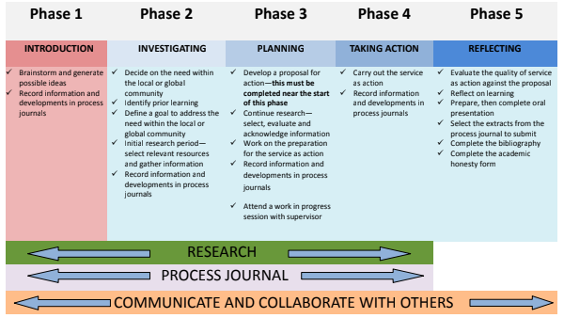

Who will assist?

Each teacher will act as a mentor for a group of students, guiding and assisting them throughout the year and their project/s. Three Year 3 teachers will be involved to lead and coordinate with the additional guidance of the MYP coordinator.

The mentors are there to assist students but they are not responsible for getting the projects completed, the students need to take ownership of their own projects.

Assessment:

Use of the rubric outlined from the IB. Criterion A - D as outlined in the community project booklet.

Standardization of The Community Project:
- Use of MYP command word list.
- Examples to help moderate.
- Checklists and Rubrics
- Objective use of the rubrics
- List of evidence could be provided.
- Explanation of the rubrics
- Oral and written marked the same.
- Awareness of mother tongue

Timeline: Outlined in community project booklet in reference to phases. Phase 1-5.

